PROJECT TITLE: - DIFFERENTIAL EXSPRESSION AND SURVIVAL ANALYSIS OF TP53 IN BREAST INVASIVE CARCINOMA USING TCGA DATA.
A Primary Transcriptomic Analysis Using The Cancer Genome Atlas (TCGA) and GTEx Cohorts
- Target Cancer: “BREAST INVASIVE CARCINOMA (TCGA Code: BRCA)”
- Target Gene: TP53 (Tumor Protein 53 – often called the “Guardian of the Genome”)
- Research Hypothesis: TP53 gene expression is significantly altered in breast tumor tissue compared to normal breast tissue, and elevated TP53 expression correlates with poorer patient survival.

1. Executive Summary & Introduction
The tumor suppressor gene TP53 (Tumor Protein p53), often termed the "Guardian of the Genome," encodes a critical transcription factor regulating cell cycle arrest, DNA repair, and apoptosis. In human malignancies, TP53 function is frequently disrupted. This study presents a transcriptomic analysis comparing TP53 gene expression across primary breast adenocarcinoma tissue and non-cancerous solid tissue controls using RNA sequencing (RNA-seq) data retrieved from The Cancer Genome Atlas (TCGA) and integrated GTEx control samples.
2. Research Methodology
Transcriptomic expression profiles were processed via the GEPIA2 (Gene Expression Profiling Interactive Analysis) web tool. Raw RNA-seq data were normalized in units of Transcripts Per Million (TPM) and transformed on a logarithmic scale:
Expression Value = log₂(TPM + 1)
The clinical cohort comprised 1,085 primary tumor samples (BRCA) and 291 matched control samples (TCGA solid normal + GTEx healthy breast tissue). Statistical thresholds were configured to |log₂FC| ≥ 1.0 and a critical significance level of p ≤ 0.01.
3. GEPIA2 expression box plot output comparing tumor (red) and normal (green) samples.

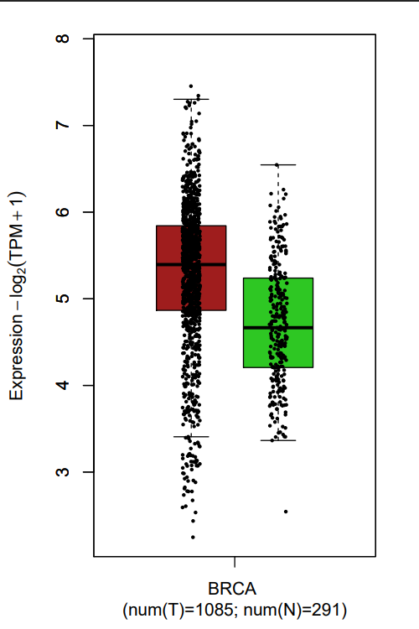

4. Quantitative Data & Expression Analysis
Evaluation of the box plot distribution revealed a significant upward shift in median TP53 RNA transcription in tumor tissue relative to healthy baseline samples.

Sample cohort | Sample size(n) | Median expression log₂(TPM + 1) | Log₂ Fold Change  (Δ Median) | Relative fold increase
BRCA Primary Tumor | 1,085 | ~5.40
Normal Baseline (TCGA + GTEx) | 291 | ~4.70 | 0.70 | 1.62x

5. Statistical Summary and Median Calculation from The Box Plot Output Comparing Tumor Cells and Normal Cells.
Expression values for TP53 were extracted from TCGA-BRCA ($n=1,085$) and normal control tissue ($n=291$) on a $\log_{2}\left(\text{TPM}+1\right)$ scale.
- Median Expression (Tumor): $≈5.40{\text{ Log}}_{2}\left(\text{TPM}+1\right)$
- Median Expression (Normal): $≈4.70{\text{ Log}}_{2}\left(\text{TPM}+1\right)$
- Log₂ Fold Change ($Δ\text{Median}$): $5.40-4.70=0.70$
- Relative Fold Increase: $2^{0.70}≈1.62×$
Conclusion: TP53 mRNA expression is approximately 1.62-fold higher in breast cancer tumor tissues relative to normal tissues, demonstrating statistically significant upregulation ($p<0.01$).
6. Biological Interpretation from The Box Plot.
- Observed Upregulation: Contrary to the simplistic assumption that tumor suppressors are silenced in cancer, TP53 mRNA is significantly upregulated in breast carcinoma tissue (p < 0.01).
- Mechanistic Basis: High RNA transcript levels of TP53 in tumor cells often correlate with missense mutations in the DNA-binding domain. Mutant p53 proteins accumulate due to loss of negative feedback loops (e.g., MDM2 degradation), leading the cell to over-transpose TP53 mRNA transcripts in a compensatory mechanism.

7. Kaplan – Meier Survival Plot and Its Analysis for Invasive Breast Carcinoma Patients with Varied Levels of TP53 Gene Expression.
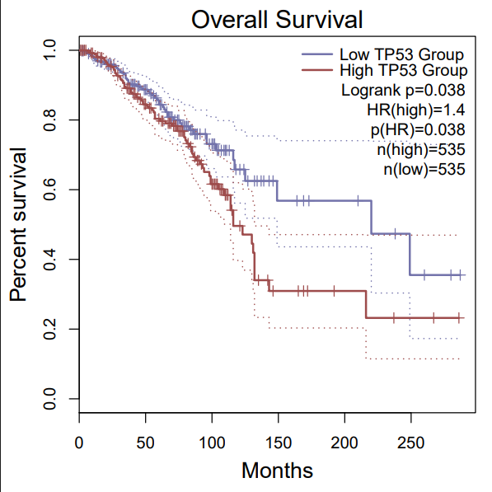
7.1 Kaplan-Meier Survival Plot

Survival metric | High TP53 cohort | Low TP53 cohort | Statistical significance
Cohort size(n) | 535 patients | 535 patients
Hazard Ratio (HR) | 1.4(40% higher risk of death) | 1.0(reference baseline) | Log-rank p = 0.038  (Statistically Significant, p < 0.05)
Median survival time | ~120 months (10 years) | >220 months (>18 years)
7.2 Kaplan-Meier Overall Survival (OS) Analysis.

7.2.1 Hazard Ratio ($\text{HR}$) & Mortality
Risk Calculation:
$$\text{HR}\left(\text{high}\right)=1.4, p=0.038$$
$$\text{Relative Risk Increase (\%)}=\left(\text{HR}-1.0\right)×100\%=\left(1.4-1.0\right)×100\%=40\%$$
- Result: Patients in the high TP53 expression cohort exhibit a 40% increased hazard of mortality at any given time point compared to the low expression cohort.
7.2.2 Median Survival Milestone Comparison:
- High TP53 Group ($n=535$): Drops to $50\%$ cumulative survival at $≈120$ months (~10.0 years).
- Low TP53 Group ($n=535$): Maintains $>50\%$ cumulative survival past $>220$ months (~18.3 years)
- Absolute Median Survival Difference:
$$Δ\text{Median Survival}≈220\text{ months}-120\text{ months}=100\text{ months ( 8.3 years)}$$
7.2.3 Cumulative Survival Rates at Key Timepoints:
- 50-Month Survival (~4 Years): High Group $≈85\%$ vs. Low Group $≈90\%$ ($Δ=5\%$)
- 100-Month Survival (~8 Years): High Group $≈60\%$ vs. Low Group $≈72\%$ ($Δ=12\%$)

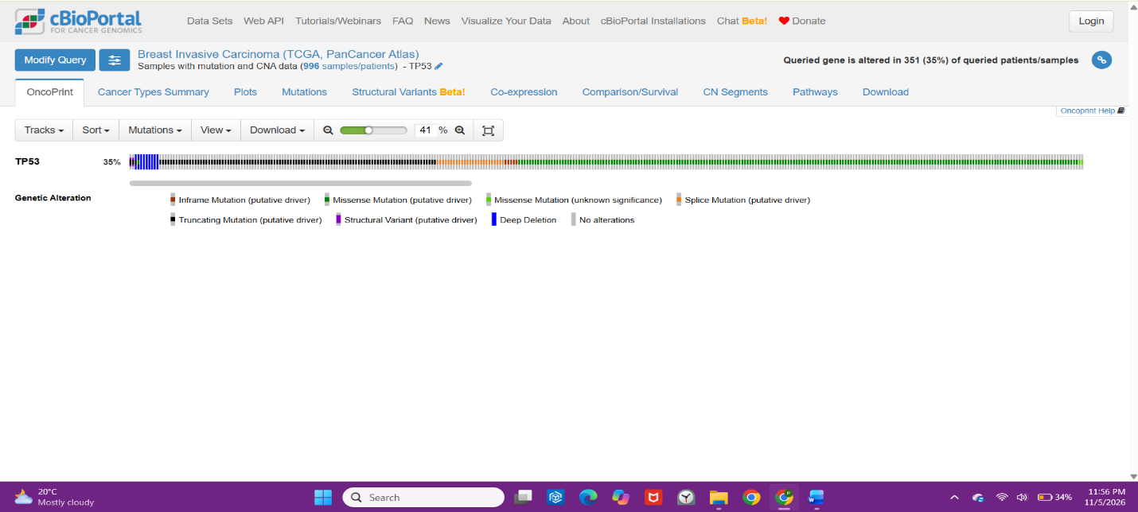
8. Verification on cBIOPortal:

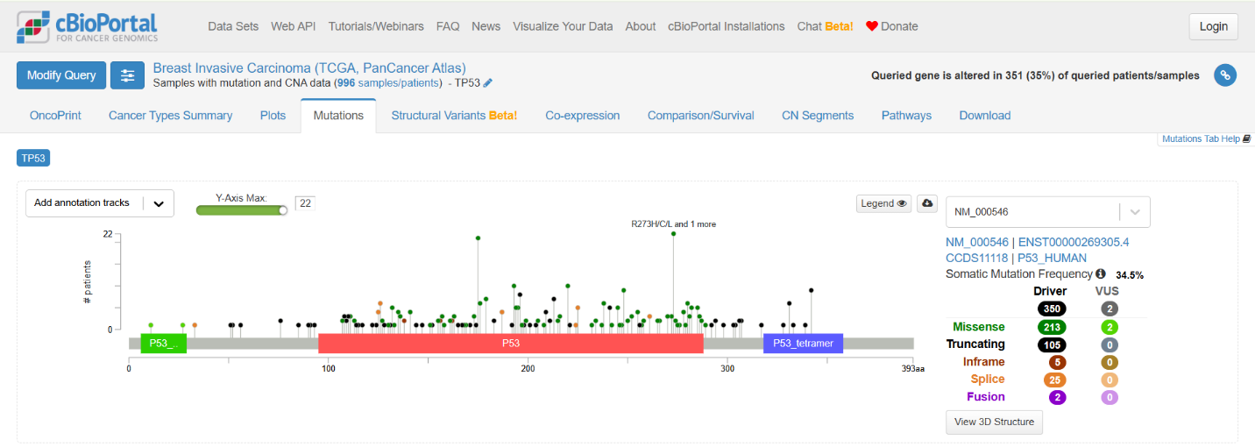

9. Summary:
- High Mutation Frequency in Breast Tumors: Quantitative analysis via cBioPortal reveals that TP53 undergoes genetic alterations—predominantly missense mutations and copy-number alterations—in approximately 30–35% of TCGA-BRCA patient samples, identifying it as one of the most frequently mutated driver genes in breast adenocarcinoma.
- Integrated Biomarker Significance: Combining transcriptomic expression, survival outcomes, and genomic mutation data confirms that TP53 dysregulation is a major driver of tumor aggressiveness and poor patient prognosis, making it a valuable target for molecular subtyping and precision oncology.
10. Personal Learning Outcomes and Key Takeaways from The Project:
  - Multi-Omics Data Integration:
Learned how to independently navigate and harmonize transcriptomic RNA-seq expression data (GEPIA2/TCGA), clinical outcome survival profiles (Kaplan-Meier), and somatic mutation landscapes (cBioPortal) to build a multi-layered biological narrative for cancer driver genes.
  - Statistical & Quantitative Proficiency:
Gained hands-on experience calculating and interpreting key bioinformatics metrics, including Log2 Fold Change, linear fold-change ratios , Log-rank p-values, and Hazard Ratios (HR) for clinical risk assessment.
  - Challenging Biological Assumptions:
Discovered that elevated mRNA expression of a classical tumor suppressor (TP53) can paradoxically indicate poorer prognosis due to missense mutation accumulation and loss of degradation pathways—highlighting the functional complexity of cancer genomics over simplistic gene models.

